Data Analysis Assignment | Name

1. Data Summary

Frequency Distribution Graph
Mean | Mode | Median | Range | Standard Deviation

2. Item Analysis

Question | 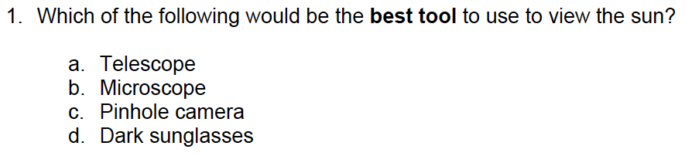
Item # | Upper | Lower | Difference | Discrimination | Total | Difficulty
A
B
C *
D
Item Analysis
Possible Adjustments

Question | 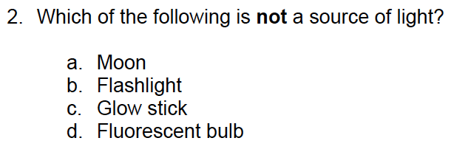
Item # | Upper | Lower | Difference | Discrimination | Total | Difficulty
A *
B
C
D
Item Analysis
Possible Adjustments

Question | 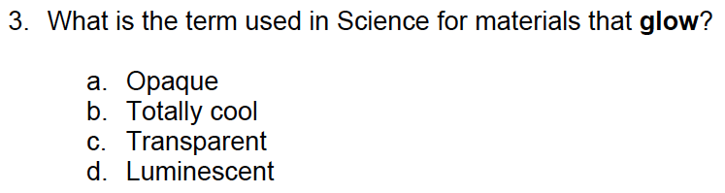
Item # | Upper | Lower | Difference | Discrimination | Total | Difficulty
A
B
C
D *
Item Analysis
Possible Adjustments

Question | 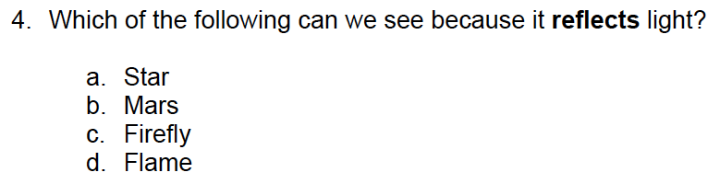
Item # | Upper | Lower | Difference | Discrimination | Total | Difficulty
A
B *
C
D
Item Analysis
Possible Adjustments

Question | 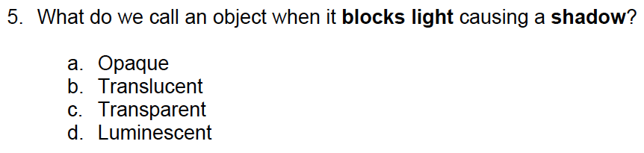
Item # | Upper | Lower | Difference | Discrimination | Total | Difficulty
A *
B
C
D
Item Analysis
Possible Adjustments

Question | 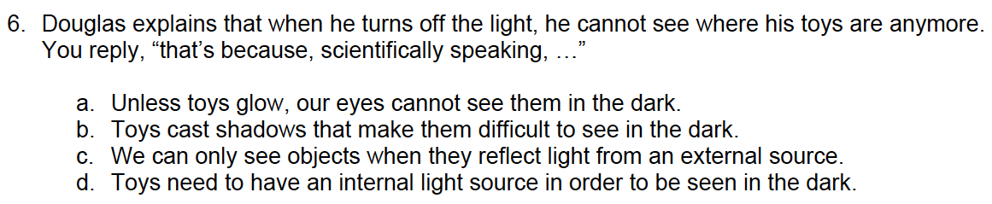
Item # | Upper | Lower | Difference | Discrimination | Total | Difficulty
A
B
C *
D
Item Analysis
Possible Adjustments

Question | 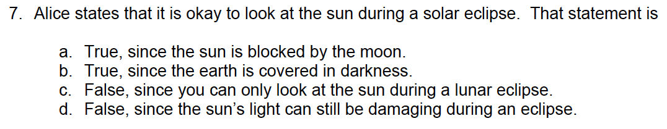
Item # | Upper | Lower | Difference | Discrimination | Total | Difficulty
A
B
C
D *
Item Analysis
Possible Adjustments

Question | 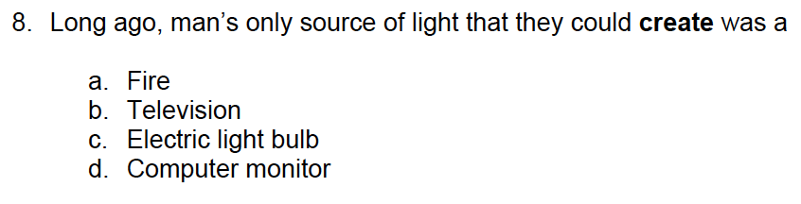
Item # | Upper | Lower | Difference | Discrimination | Total | Difficulty
A *
B
C
D
Item Analysis
Possible Adjustments

Question | 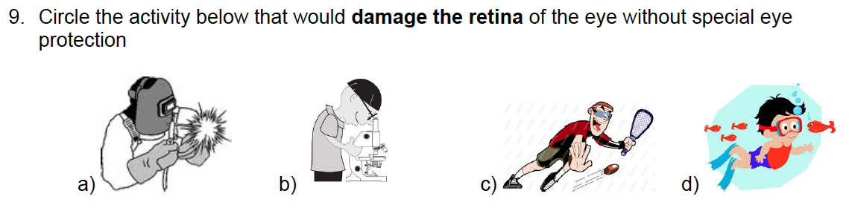
Item # | Upper | Lower | Difference | Discrimination | Total | Difficulty
A *
B
C
D
Item Analysis
Possible Adjustments

Question | 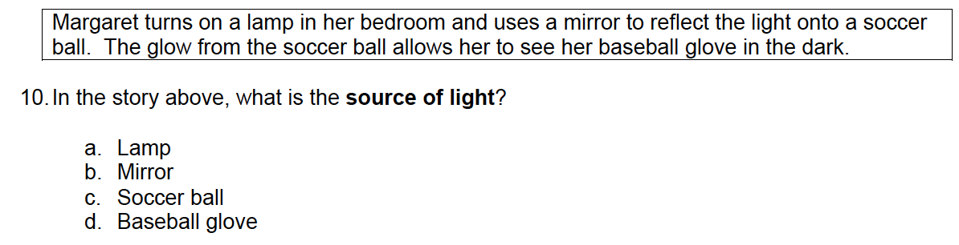
Item # | Upper | Lower | Difference | Discrimination | Total | Difficulty
A *
B
C
D
Item Analysis
Possible Adjustments
3. Recommendations
What decisions about the class, unit, instruction or the test can be reached based on the examination results? For example, is the class ready to go on to the next set of outcomes? Is there a particular outcome or concept that will need to be retaught? How would you adjust for individual students?

